**Computer Networks Assignment**

Objective:

1. To familiarize students with Cisco Packet Tracer.
2. To set up a peer-to-peer (P2P) communication network.
3. To study different types of network cables and their color codes.
4. To document the observations and save the configuration file in a GitHub repository.

Requirements:

1. Cisco Packet Tracer software.
2. A GitHub account and a repository for lab assignments.
3. Access to Google Classroom for submission.

GitHub Account link:

<https://github.com/ArpanSurin/Network-Lab-Assignments>

Instructions:Part 1: Introduction to Packet Tracer

1. Ensure you have Cisco Packet Tracer installed on your computer. If not, download it from the Cisco Networking Academy website.
2. Open Packet Tracer and explore the user interface. Familiarize yourself with different tools and components available in the software.



Part 2: Peer-to-Peer Communication Setup

1. Open Packet Tracer and create a new network.
2. Add two PCs to the workspace.
3. Use a copper straight-through cable to connect the FastEthernet0 port of PC0 to the FastEthernet0 port of PC1.

4)Assign IP addresses to both PCs:

PC0: IP address: 192.168.1.1, Subnet Mask: 255.255.255.0

PC1: IP address: 192.168.1.2, Subnet Mask: 255.255.255.0

1. Open the command prompt on PC0 and ping PC1 using the command ping 192.168.1.2.

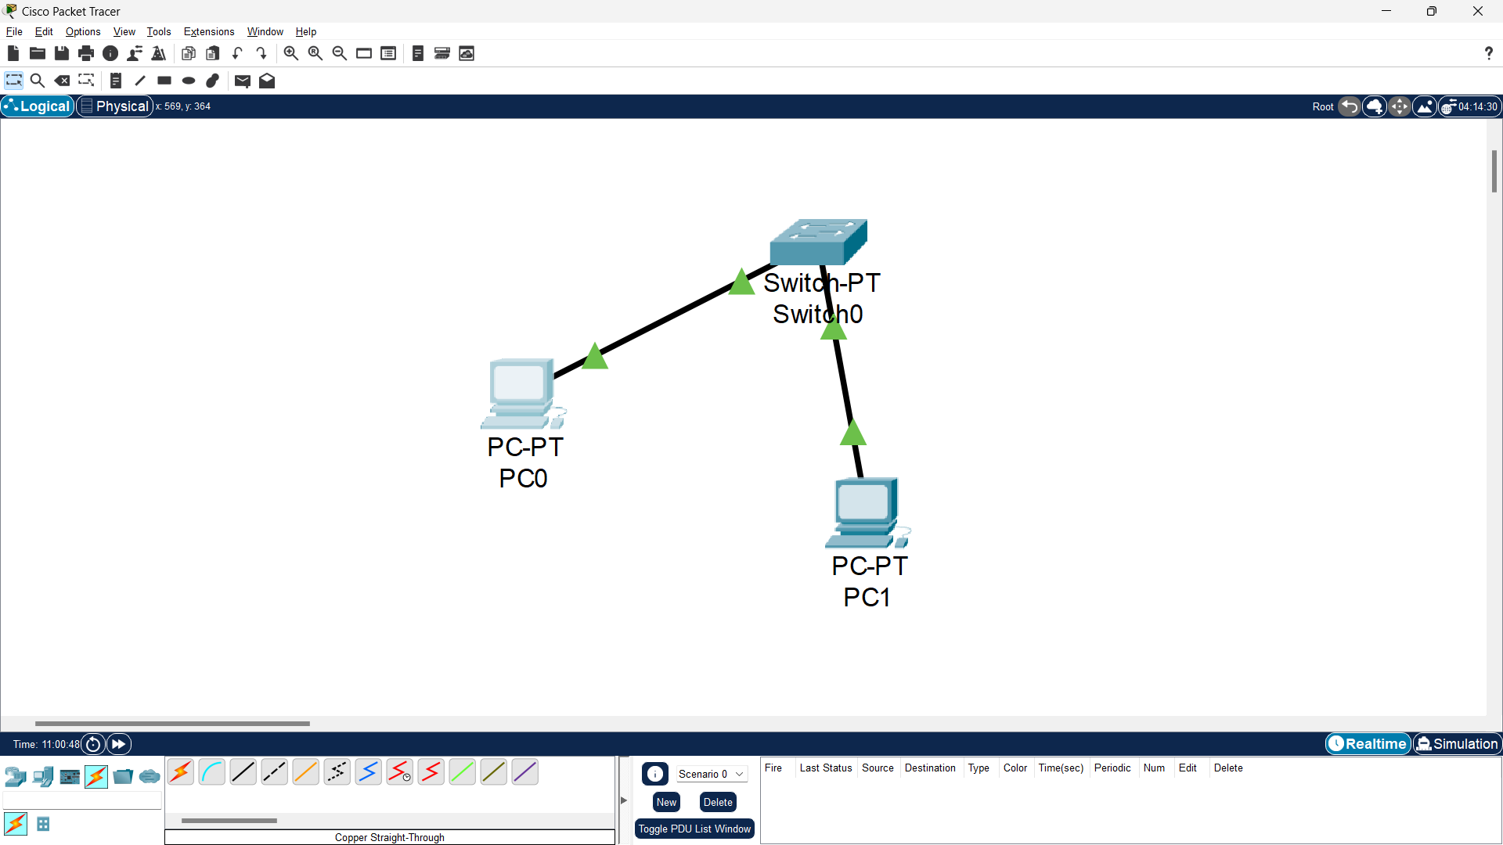

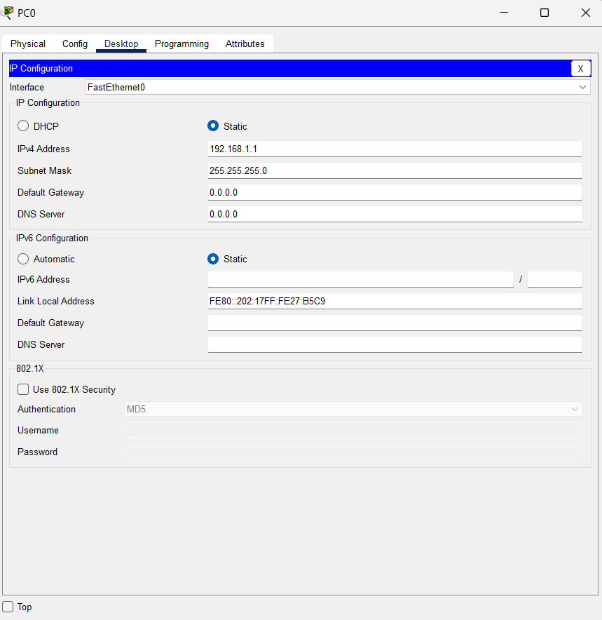

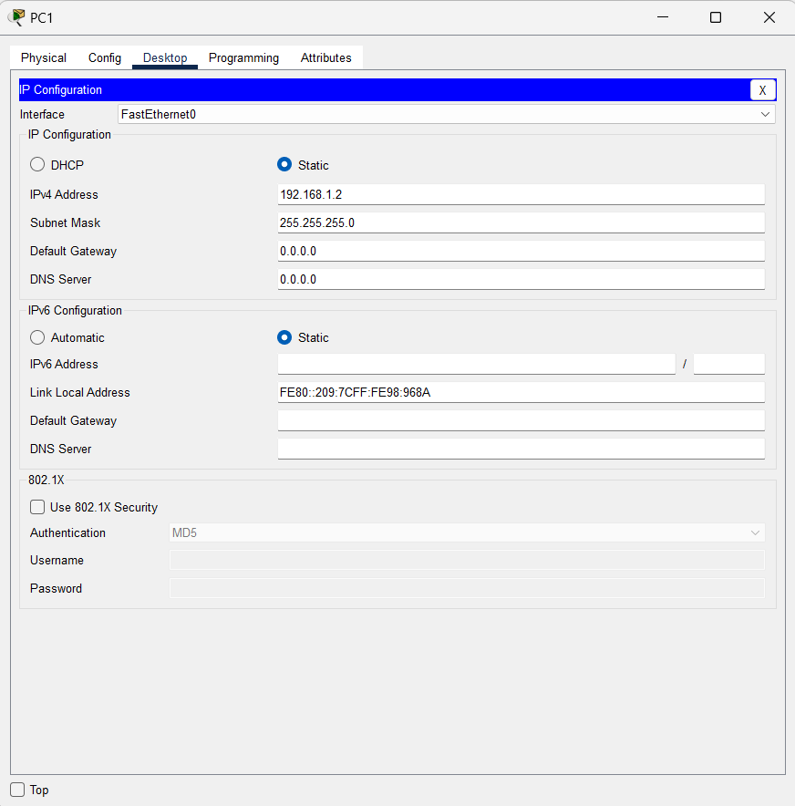

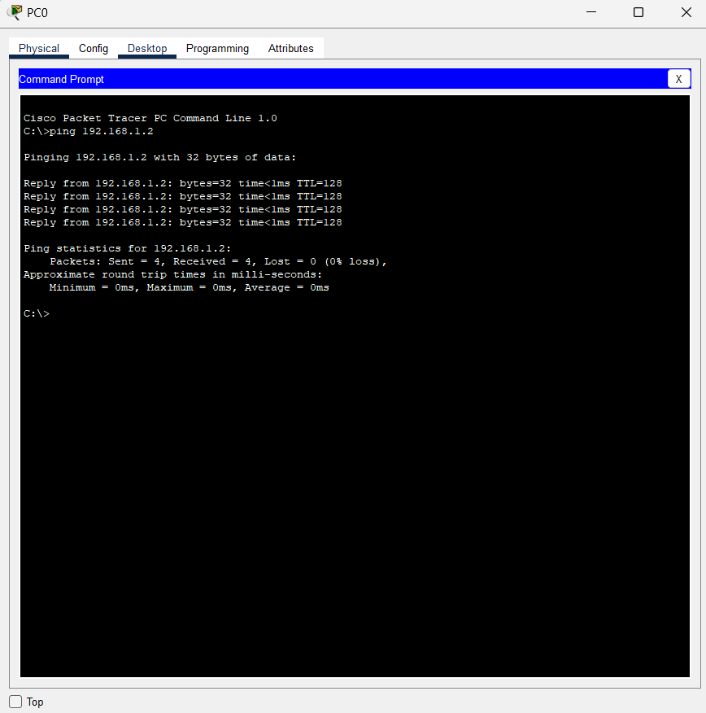

Part 3: Study of Network Cables and Color Codes

1)Research and document the different types of network cables used in computer networking (e.g., copper straight-through, copper crossover, fiber optic cables).

2)Document the standard color codes for copper straight-through and crossover cables.

3)Explain the purpose of each type of cable and where they are used in a network.

**Answers**

Types of Network Cables in Computer Networking

1. **Copper Cables**

Copper cables are widely used due to their cost-effectiveness and ease of installation. They are typically used for Ethernet connections in local area networks (LANs).

a. Straight-Through Cable

- Purpose: Used to connect different types of devices (e.g., a computer to a switch or router).

- Wiring Configuration: Both ends of the cable have the same pin configuration.

- Standard Color Codes (T568B):

- Pin 1: White/Orange

- Pin 2: Orange

- Pin 3: White/Green

- Pin 4: Blue

- Pin 5: White/Blue

- Pin 6: Green

- Pin 7: White/Brown

- Pin 8: Brown

b. Crossover Cable

- Purpose: Used to connect similar devices (e.g., a computer to another computer or a switch to another switch).

- Wiring Configuration: One end follows the T568A standard, and the other end follows the T568B standard.

- Standard Color Codes:

- T568A End:

- Pin 1: White/Green

- Pin 2: Green

- Pin 3: White/Orange

- Pin 4: Blue

- Pin 5: White/Blue

- Pin 6: Orange

- Pin 7: White/Brown

- Pin 8: Brown

- T568B End:

- Pin 1: White/Orange

- Pin 2: Orange

- Pin 3: White/Green

- Pin 4: Blue

- Pin 5: White/Blue

- Pin 6: Green

- Pin 7: White/Brown

- Pin 8: Brown

2. Twisted Pair Cables

Twisted pair cables are a type of copper cabling that reduces electromagnetic interference and crosstalk between pairs of wires.

a. Unshielded Twisted Pair (UTP)

- Features: No shielding; relies on twisting to reduce interference.

- Common Standards: Cat5e, Cat6, Cat6a, Cat7, Cat8.

- Applications: Used in most Ethernet networks.

b. Shielded Twisted Pair (STP)

- Features: Shielding around each pair of wires and/or the cable itself.

- Applications: Used in environments with high electromagnetic interference.

3. Coaxial Cables

Coaxial cables are used for high-frequency signals and provide better shielding from interference.

- Structure: Consists of a central conductor, insulating layer, metallic shield, and outer insulating layer.

- Common Uses: Cable internet, cable TV, and certain types of Ethernet networks (e.g., 10Base2, 10Base5).

4. Fiber Optic Cables

Fiber optic cables use light to transmit data, offering higher bandwidth and longer transmission distances compared to copper cables.

a. Single-Mode Fiber (SMF)

- Core Diameter: 8-10 microns.

- Light Source: Laser.

- Distance: Suitable for long-distance communication (up to hundreds of kilometers).

- Applications: Long-haul telecommunications, internet backbone, and cable TV.

b. Multi-Mode Fiber (MMF)

- Core Diameter: 50-62.5 microns.

- Light Source: LED.

- Distance: Suitable for shorter distances (up to 2 kilometers).

- Applications: Local area networks (LANs), data centers, and short-distance communication.

5. Hybrid Cables

Hybrid cables combine multiple types of cables within a single sheath, such as power and fiber optic cables. They are used in specific applications where both data and power transmission are required over the same cable run.

Standard Color Codes for Copper Straight-Through and Crossover Cables

Straight-Through Cable (T568B Standard)

- Pin 1: White/Orange

- Pin 2: Orange

- Pin 3: White/Green

- Pin 4: Blue

- Pin 5: White/Blue

- Pin 6: Green

- Pin 7: White/Brown

- Pin 8: Brown

Crossover Cable

- T568A End:

- Pin 1: White/Green

- Pin 2: Green

- Pin 3: White/Orange

- Pin 4: Blue

- Pin 5: White/Blue

- Pin 6: Orange

- Pin 7: White/Brown

- Pin 8: Brown

- T568B End:

- Pin 1: White/Orange

- Pin 2: Orange

- Pin 3: White/Green

- Pin 4: Blue

- Pin 5: White/Blue

- Pin 6: Green

- Pin 7: White/Brown

- Pin 8: Brown

Purpose and Applications of Each Cable Type

1. Copper Straight-Through Cable

- **Purpose**: Connects different types of network devices, such as computers to switches, routers, or modems.

- **Applications**: Commonly used in office networks, home networks, and data centers for connecting end-user devices to the network infrastructure.

2. Copper Crossover Cable

- **Purpose**: Connects similar network devices, such as computer-to-computer, switch-to-switch, or router-to-router.

- **Applications**: Used in scenarios where direct device-to-device communication is needed without an intermediary network device.

3. Twisted Pair Cables (UTP and STP)

- **Purpose**: Provides network connections with reduced interference and improved performance.

- **Applications**:

- **UTP**: Widely used in Ethernet networks for connecting computers, switches, routers, and other devices.

- STP: Used in environments with high levels of electromagnetic interference, such as industrial settings.

4. Coaxial Cables

- Purpose: Transmits high-frequency signals with minimal interference.

- Applications: Used for cable television, cable internet connections, and specific Ethernet network implementations.

5. Fiber Optic Cables

- Purpose: Transmits data over long distances at high speeds with minimal signal loss.

- Applications:

- Single-Mode Fiber (SMF): Used in long-distance telecommunications, internet backbone infrastructure, and cable TV networks.

- Multi-Mode Fiber (MMF): Used in local area networks (LANs), data centers, and short-distance communication setups.

6. Hybrid Cables

- Purpose: Combines multiple types of cables to provide both data and power transmission.

- Applications: Used in specialized environments where both power and data need to be delivered over the same cable, such as in certain telecommunications and industrial applications.